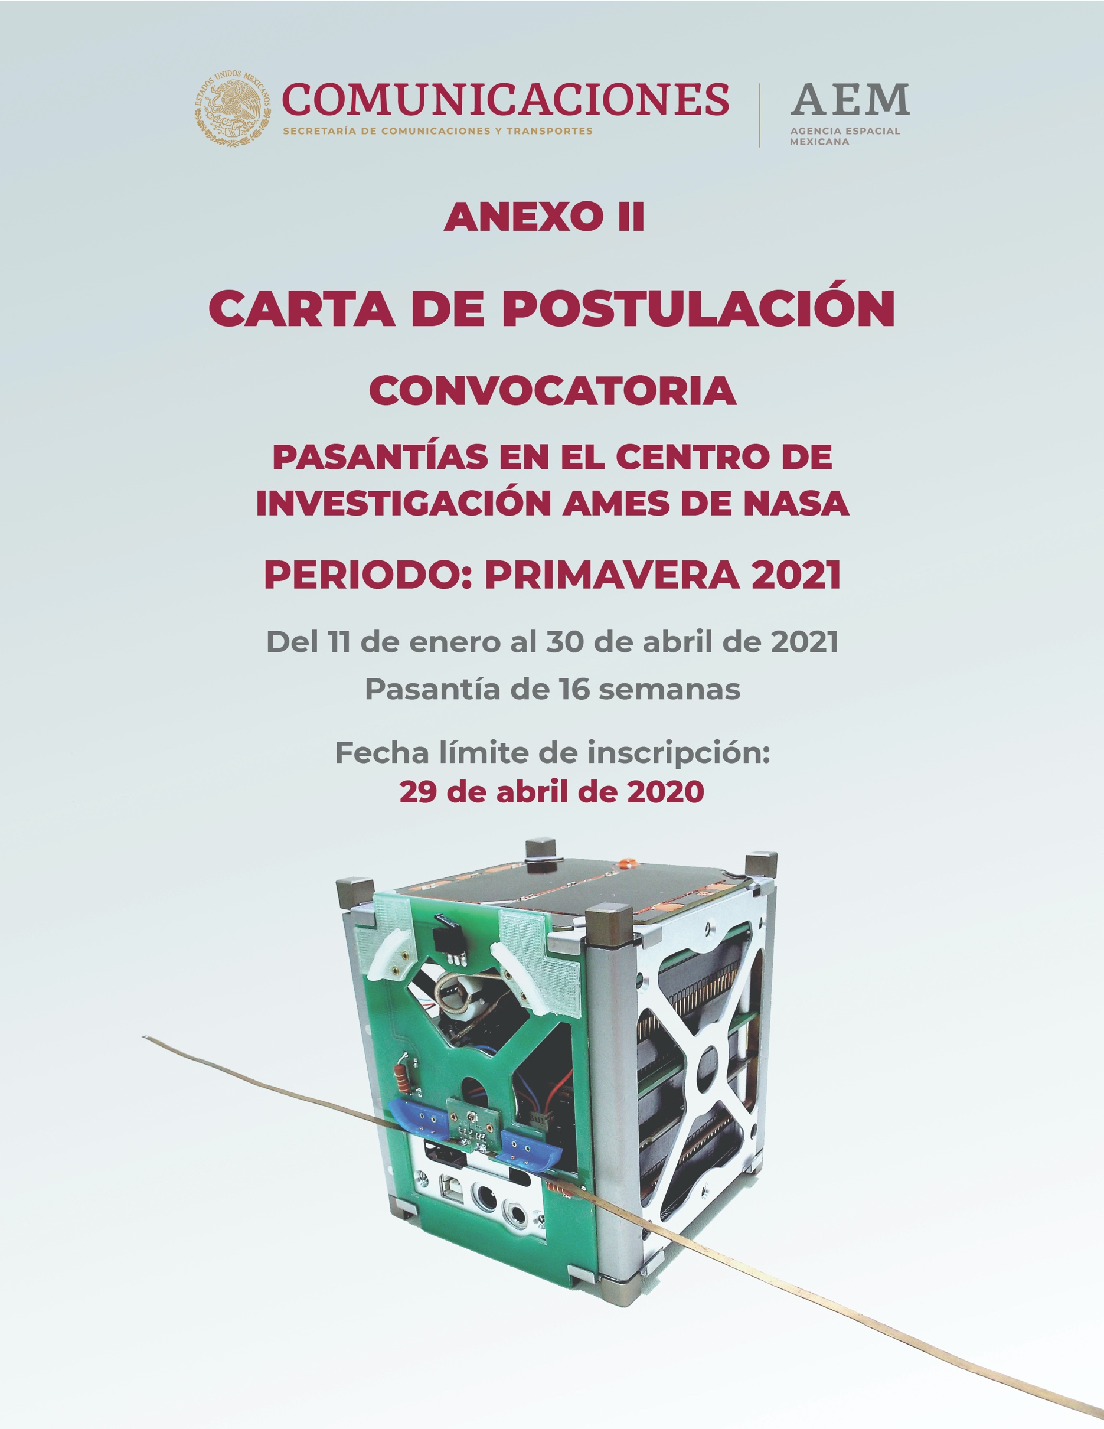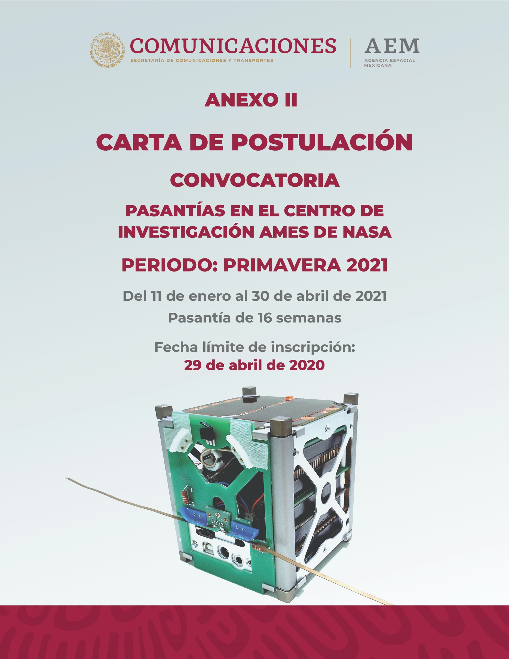

ANEXO II

Guía de Proyectos.

|  |  |
| --- | --- |
| **PROJECT** | **PROJET TITLE** |
| 1 | Shockwave Radiation Testing |
| 2 | Robotic Sample Transfer Automation |
| 3 | Rover-Instrument Automation and Data Integration |
| 4 | Synthetic Biomaterials: A Multi-Scale Approach |
| 5 | Genomics of Single Cell Mechanos-transduction in Mouse Embryonic Stem Cells |
| 6 | The Influence of Mechanical Unloading on Biological Function |
| 7 | Machine Learning Classification of transit-like signals |
| 8 | Deep Learning Binarization of Vascular images |
| 9 | Image Análisis software basad on neural nets and “Deep learning” |
| 10 | Biosensor Development |
| 11 | Microbial Factories for Solar System Exploration |
| 12 | NASA Ames Astrobee Facility |
| 13 | Space Structure Assembly Robotics – The Automated Reconfigurable Mission Adaptive Digital Assembly System (ARMADAS) Project. |
| 14 | Aerothermodynamics Modeling |
| 15 | Hybrid Rocket Modeling and Experiments |
| 16 | Orbit Analysis for LEO CubeSats and Low Lunar Orbits |
| 17 | Astrobee Robot Software |
| 18 | Analyzing satellite and drone imagery from the Atacama Desert, a Mars analog environment in Chile. |
| 19 | Experimental Visualization of Shock Structure in a Miniature Arc Jet |
| 20 | Nanotechnology in electronics and sensor development |
| 21 | Novel Planetary Robotic Sensor Development |
| 22 | Advanced Life Support |
| 23 | Control Internship Position |
| 24 | Experimental Aero-Physics Engineering Intern |
| 25 | Methods for High Order Finite Element Schemes |
| 26 | Lunar Topographic Products from Orbital Images |
| 27 | SUPERball 2.0 Tensegrity Robot |
| 28 | Evaluation of Biomedical Devices for Exploration Missions |
| 29 | Erosional Studies of Mars and Earth Using Digital Terrain Models |
| 30 | Rotorcraft Aeromechanics |
| 31 | Deep Learning for Satellite Imagery (DELTA) |
| 32 | Robotic 3D Mapping of Lunar Skylights |
| 33 | Thermal Mapping for River Measurement from a UAV |
| 34 | 3D Microscopy and Novel Optical Sensing for Planetary Exploration |
| 35 | Novel Media Visualization |
| 36 | Mini Hyperspectral Camera for Planetary Surface Study |
| 37 | Lunar and Planetary Sample Science |
| 38 | Automated Planning for in-Vehicle Robotics |





























































